Personal Portfolio Website Plan

# Your Name: **James Wigle**

# Ideas for your website

Determine how you will use your personal portfolio website to showcase your skills.

Idea 1:

Personal section:

About me with most information pertaining to my hobbies or expertise relating to the filed of choice. This would be a small paragraph on the front page or would separate into a smaller introduction paragraph on the main page and a section for further details on hobbies.

Idea 2:

Work history section:

This would be limited to industry related roles or others that may show valuable skills. Within each option, the included categories will be tasks, position, start and end date, reason for leaving, and a short description.

Idea 3:

Experience section:

Although similar to the work history section, rather than job positions, the focus would revolve around projects or accomplishments within my jobs/schooling. These will be told in a story format to make them seem more interesting.

Idea 4:

Awards section:

This will list any awards I have received from school, work, or other. It will include the date received, a small description, and an image referencing the reward.

Idea 5:

Education section:

This will include my important education including GCSEs, college degrees, and certificates. Each one will include date received, the name of both the school and degree, and the degree description.

# Website Plan

|  |  |  |
| --- | --- | --- |
| Topic | Questions | Answers |
| Purpose of Website | What is the purpose and goal of the website? | The purpose of the website is to showcase my abilities and skills to potential employers in an easily segmented format. It should contain any necessary information that potential employers may need to know to make an informed decision. |
| Target Audience | Describe the target audience (age, gender, demographics) | The target demographic will be the millennial generation as they are the most likely to be the age of my employer or their representative. My desired industry is male dominated however most reviews are through HR which is statistically more feminine so my website should target both audiences. Seeing as my desired industry is in the cyber security field, including ideas pertaining to technology is pertinent. |
| Graphics | What graphics will you use on the website? | Including images relating to pop culture could assist in matching my demographic. For example, a hidden fake back door leading to an image of Obi Wan saying “hello there” shows a sense of humor, technical prowess, and a relatable personality. Most graphics will relate to my past experiences in the industry or a comedic/relatable message. All will need to be owned by me or copyright free. |
| Color | What colors will you use within the site to enhance the purpose and brand? | I will use earthy tones that will be less harsh on the eyes. For example, a light gray for text on a mossy green would look elegant. To show highlighted options or as an accent colour, I would use a muted orange. Sort of matching a sunset. These colours bring a calming sense to a viewer and contrast well enough to make everything legible. Another choice I’m pondering is a light gray text, slate blue background, and a dark gray/black accent. |
| Accessibility | How will the website accommodate people with disabilities? | It is difficult to give everyone accommodations through a website. For example, those who struggle with seeing can’t easily read a website. Including a text to speech option may be helpful. Anything that may not be generally known will have an embedded hyperlink to take the user to a recourse on the topic. |
| Project Timeline | Identify the project timeline | The project should be completed following the directions between homework 1-5. This will take until approximately mid-December. |

# Wireframe

Sketch the wireframe for your home page below.

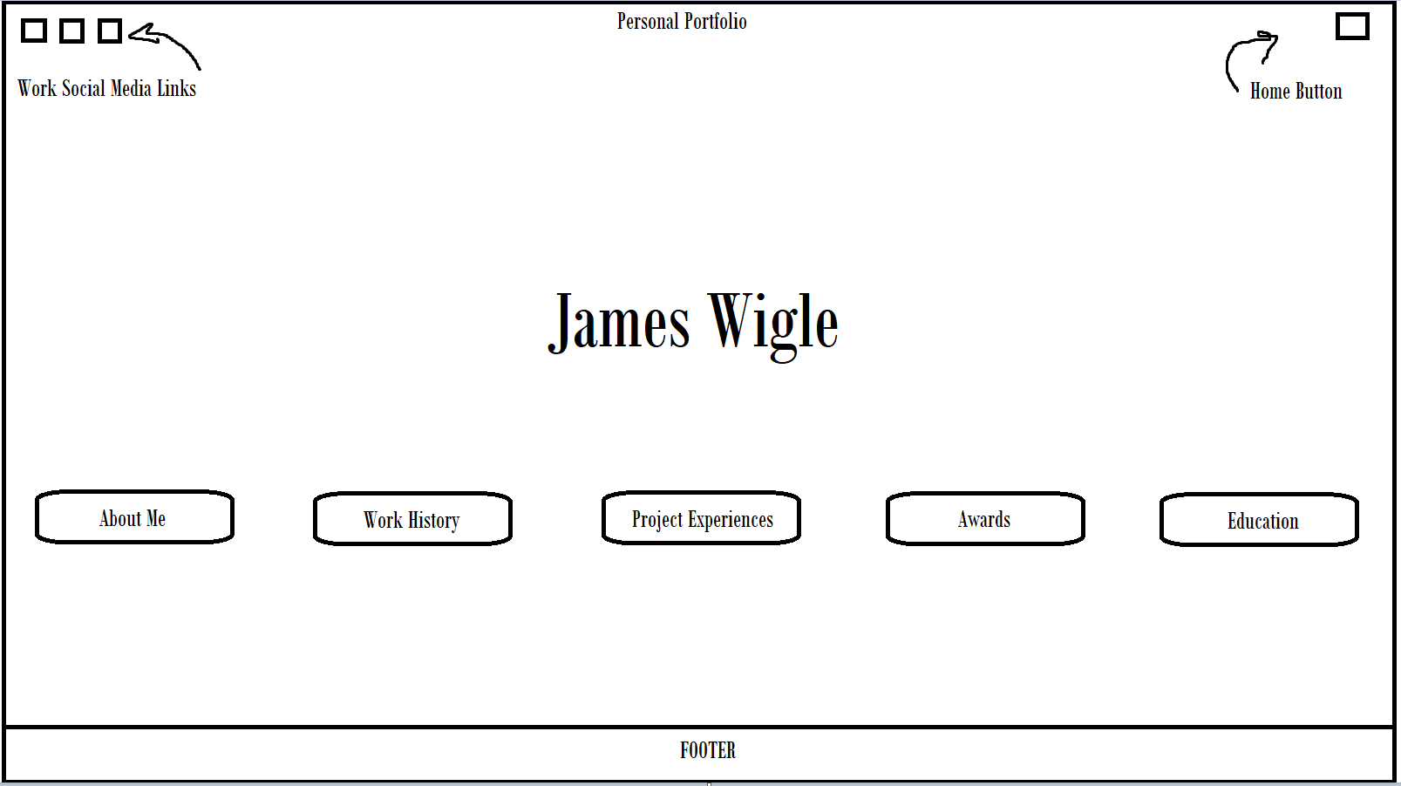

Drawn in MSPaint

# Site map

Create a site map for the website below.

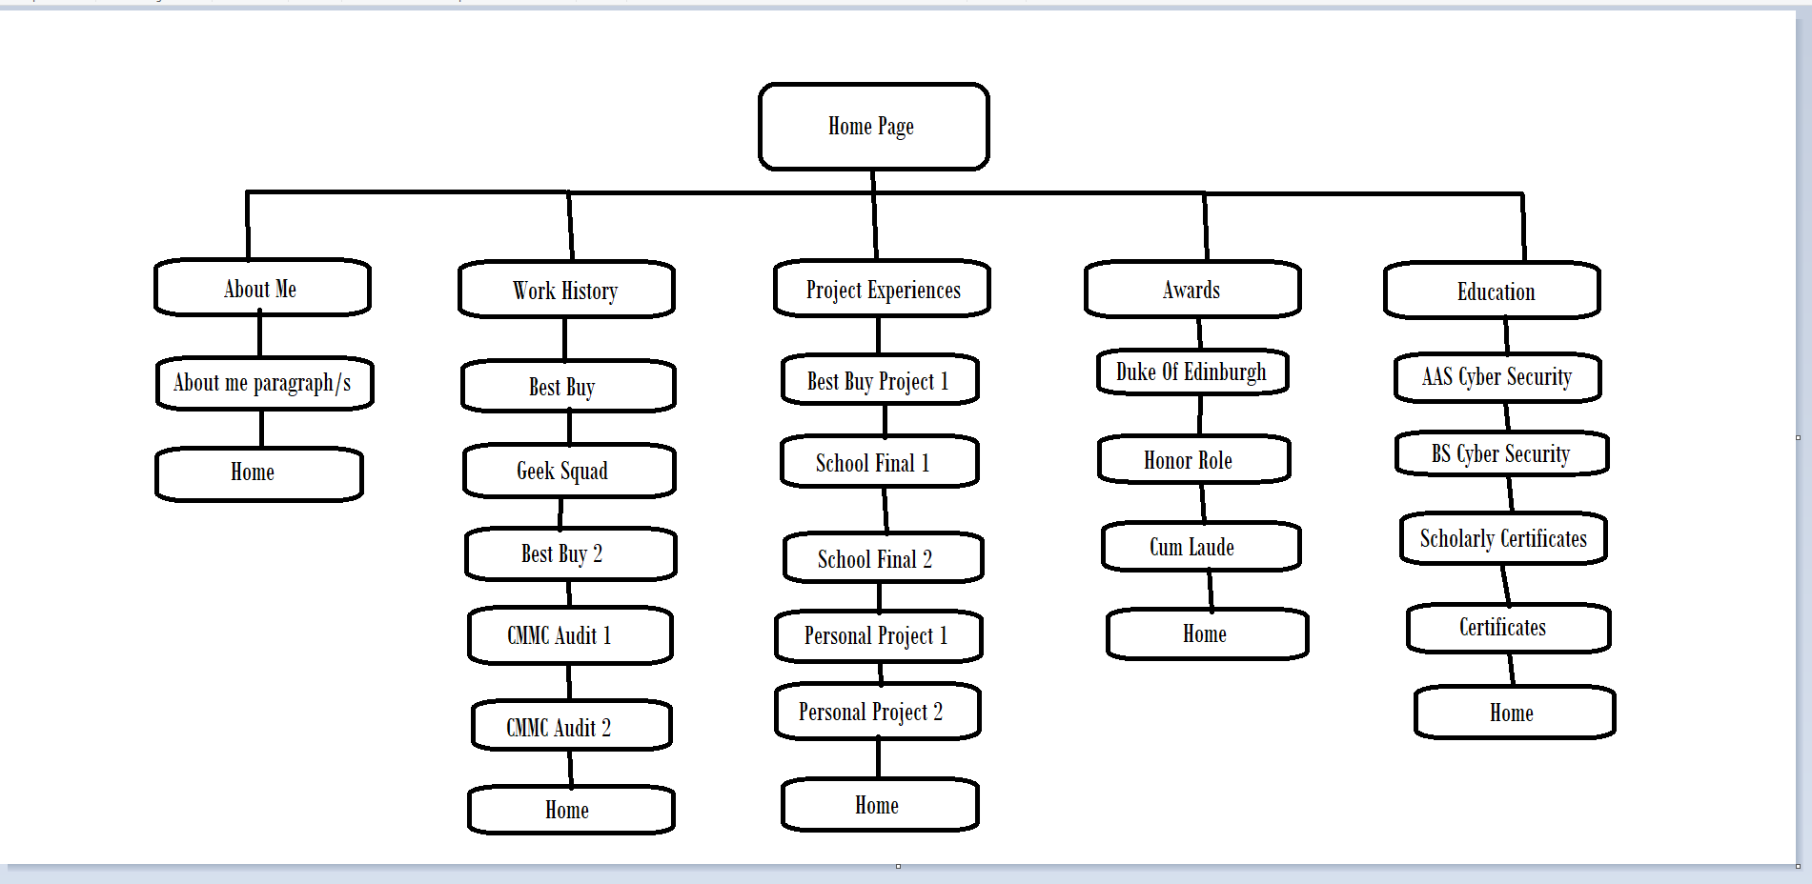

Drawn in MSPain